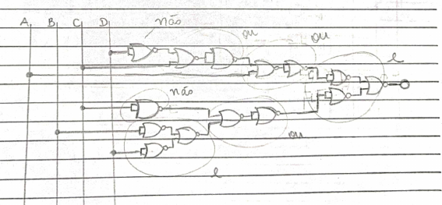

¬(¬(¬(¬(¬((¬(D+ D) + C) + (¬(D + D) + C)) + A)+¬(¬((¬(D + D) + C) + (¬(D + D) + C)) + A))+¬(¬(¬((¬(D + D) + C) + (¬(D + D) + C)) + A)+¬(¬((¬(D + D) + C) + (¬(D + D) + C)) + A)))+¬(¬(¬(¬(C+C)+¬(¬(B+B)+¬(D+D)))+¬(¬(C+C)+¬(¬(B+B)+¬(D+D))))+¬(¬(¬(C+C)+¬(¬(B+B)+¬(D+D)))+¬(¬(C+C)+¬(¬(B+B)+¬(D+D))))))

